More information, videos, and images at http://sordylathenshighschool.weebly.com

“To collect photographs is to collect the world.” – Susan Sontag
PHOTOGRAPHY
Dear Student and Families,
I would like to take this opportunity to welcome you to the digital photography program. This is an excellent opportunity for students to get an introduction to basic concepts for acquiring digital images and the process of manipulating the images using software. Student will have hands-on learning with Photoshop to make selections, crop images, adjustments, and effects. Students will produce a final portfolio of digital photographic work.

COURSE OBJECTIVES: Students will be able to…
- Learn art concepts through the elements of art and principles of design.

- Demonstrate a basic knowledge of Adobe Photoshop and Microsoft PowerPoint
- Improve and develop digital photography skills.
- Demonstrate the use of a digital camera
- Explore digital imaging in society.
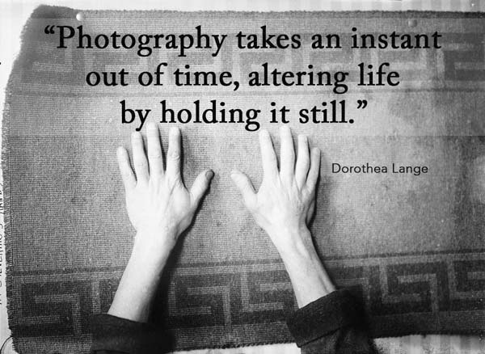
- Compose and produce well crafted digital images.
- Create projects that yield individual creativity and personal interpretation in a final portfolio

SUGGESTED PHOTOGRAPHY SUPPLIES
-1 Flash Drive for students to back-up images
- bring pen or pencil to class daily

ATTENDANCE
Please be prepared and on time for class. If you are absent it is your responsibility to find out what you missed. You will not full credit for work assigned if you have an unexcused absence. Points on long-term projects will be deducted for unexcused absence(s).
My personal goal as your photography teacher is that each student is successful in my classroom. I am always available to students that need additional help and support. I want all students to realize that the art of photography is a process that requires time and practice and can often take many revisions to perfect. Sometimes we learn the most from our mistakes. This in an introduction class where students will learn about photography skills and how to use the elements and principals of design to improve their photographs. I will be open- minded to student ideas but expect students to only bring in and take images appropriate for school. The best way to contact me if you have any questions or concerns is through email. Please give me 48 hours to respond to your emails.
Thank you,
~Mrs. Luba Sordyl
lsordyl@troy.k12.mi.us

CLASSROOM RESPONSIBILITIES
-Be on time and prepared for class
-Have a positive attitude
-Respect one another
-Use all materials with care
-Clean up after yourself
-No food or drinks by computers please

UNITS OF STUDY:
- DSLR Camera Basics and Modes
- Photoshop Introduction
- Macro photography. Understanding and applying various lighting, rule of thirds, composition, texture, color, emphasis, patterns, and harmony
- Portrait photography. Understanding cropping when working with the human figure, lighting for mood, edit of image
- Creative photography. Student will explore a variety of way to take creative photographs and edit these images.
- Photojournalism –the story and meaning in a photograph
GRADING:
- In Class Projects
- Class Participation and students desire to improve and show growth
- Self-Assessments
- Care of supplies and workspace

